# File permissions in Linux

## Project description

Review the scenario below. Then, complete the step-by-step instructions.

You are a security professional at a large organization. You mainly work with their research team. Part of your job is to ensure users on this team are authorized with the appropriate permissions. This helps keep the system secure.

Your task is to examine existing permissions on the file system. You’ll need to determine if the permissions match the authorization that should be given. If they do not match, you’ll need to modify the permissions to authorize the appropriate users and remove any unauthorized access.

## Check file and directory details

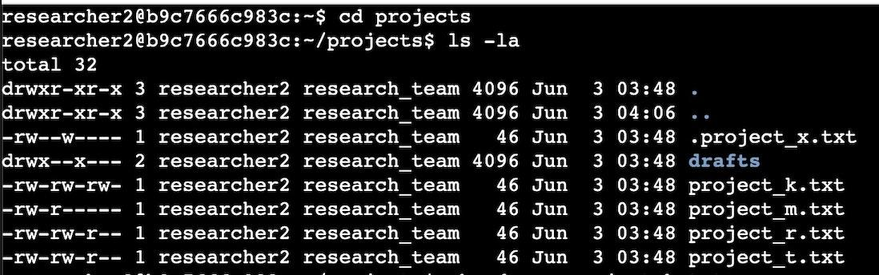

I used the command ls -la to l show the directory permissions and a shows hidden directories or files

## Describe the permissions string



Users : Read and Write permissions

Groups : Read and write permissions

Others : Read and write permissions

Theyre 3 permissions that can be granted to users groups and others . These permissions are Reading writing , and execute

.The First ,second and third letters in that string indicate the permissions allowed to the user R and W indicate that the user has permission to read and write on the file/ directory.

The letters in the 4-6 place of the permissions string indicate the same but this is for the group portion of the users.

And the letter places 7-9 show the permissions for the other users. All groups of users have the same permissions . This is indicated by the Rw in the 3 different groups .

## Change file permissions

The commands that i would use to take unauthorized permissions from the files since the organization doesnt allow others to have write permission to the files the command i would use :

Chmod o-w project_k.txt

Chmod = change mode

O-W = Others lose permissions to writing on this file.

## Change file permissions on a hidden file

the research team has archived **.project_x.txt**, which is why it’s a hidden file. This file should not have write permissions for anyone, but the user and group should be able to read the file. Use a Linux command to assign **.project_x.txt** the appropriate authorization.

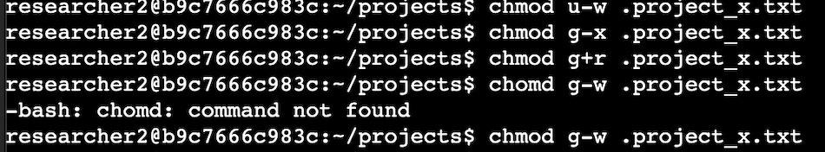

According to the documentation provided to me in the lab users had permission to write so i had to remove those permissions. Groups had permission for executions and writing but not reading which is the only permission the organization wanted to allow. So i had to remove executions and writing and add the permission for them to read the file. I was able to accomplish this using the Cmod command

## Change directory permissions

In this task, you must change the permissions of a directory. First, you’ll check the group permissions of the /home/researcher2/projects/drafts directory and then modify the permissions as required.

Only the researcher2 user should be allowed to access the drafts directory and its contents. (This means that only researcher2 should have execute privileges.)

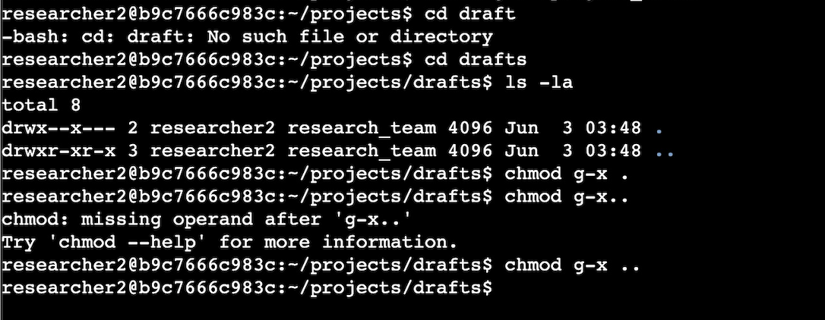

* I switched from the project files and redirected to the drafts I did this with the cd drafts command
* Then i pulled up a list of the directories using ls -la which provided me with a list of all directories public and hidden.
* From there i had to remove unauthorized permissions and i was able to accomplish this with the chmod g-x command and since there were 2 directories that the group had permisson

## Summary

All in all this lab gave me great hands on experience using linx and its CLI as well as becoming familiar with some of the commands and the administrative tasks that could be performed with it. It was great to learn using real world scenarios.